**CSS COURSE - CAPSTONE PROJECTS**

**Project 1: Web App Authentication Pages**

**Overview:**

Inmate is a software development company. Recently they have receive a contract to build a customer facing  web application. As a developer for frontend developer for Inkate, you are to build the authentication pages - registration, login, forgot password and password reset. You can find sample implementation [here](https://winners-traffic-watch.netlify.app/register)

**Registration**: Your registration page should allow users to create account by entering their **first name**, **last name**, **email**, **password**, **confirm password** and a **button**

* All input elements must have meaningful labels
* Clicking on the label should activate/select the corresponding input
* All pages must be responsive - looks nice on mobile, tablet and desktops without

**Login** : Your login page should allow users with an account to login by entering their **email** and **password** and a click on a  **button**

**Forgot Password Page**: Your page should allow users who have lost their login credentials to enter their **email** and a click on a  **button** to reset their password

**Acceptance Criteria:**

* All input elements must have meaningful labels
* Clicking on the label should activate/select the corresponding input
* All pages must be responsive - looks nice on mobile, tablet and desktops without crawl bars

**Submission:**

* Create a repository on your github account for this project
* Deploy the app to Netlify and send the url to getsuperscript@gmail.com

**Project 2: UI Mockup Design**

* Study the design below and reproduce as closely as possible
* Remember to pay close attention to details
* Ensure your design is responsive
* Share a codepen implementation of your work

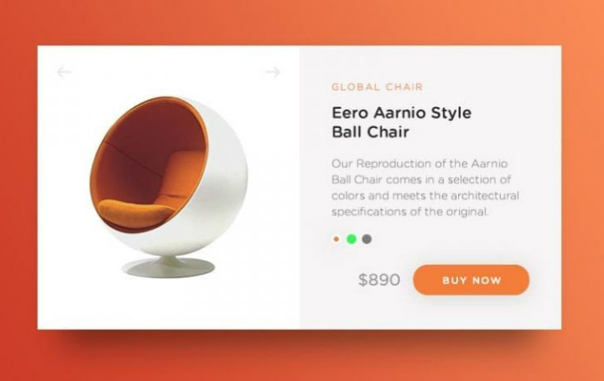

**Project 3: UI Mockup Design**

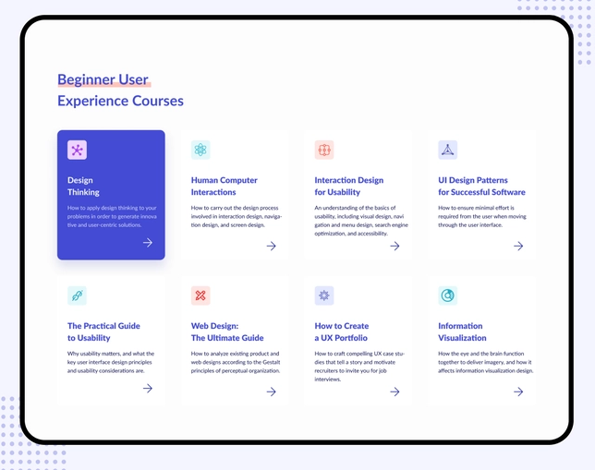

* Study the design below and reproduce as closely as possible
* Remember to pay close attention to details
* Ensure your design is responsive
* Share a codepen implementation of your work

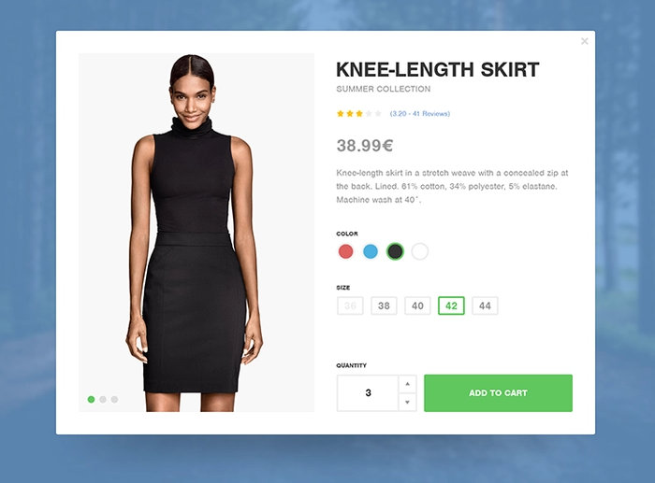

**Project 4: IG sidebar**

